**SENIOR YEAR CHECKLIST!**

Senior year is filled with many memorable moments. Homecoming, Powderpuff, Grad Bash, Prom, Senior Week, Graduation, and Life! To make this year as enjoyable as possible and give you a guideline for things that will help make sure you don’t forget anything, I have created a timeline of estimated dates to stay aware of *some* of the major events for this upcoming school year. So plan accordingly and let’s make this your best year yet!

**August: *Senior Class Officer Elections***

* Start making a list of colleges or schools you are interested in (limit to 8 or less) and find out more information on application dates and possibly visit the schools (http://www.flbog.edu/board/office/asa/admissionstour.php)

**September: *Senior class of 2018 meetings begin (1-2 times per month, officers required to attend)***

* Begin to ask one or two teachers for letters of recommendation (have a resume or list that helps to describe you, your accomplishments, goals, and leadership qualities)
* If you haven’t taken the ACT or SAT, register and prepare yourself so that you have time to take it again if needed before the initial school deadlines
* EARLY ACTION OR EARLY DECISION applications tend to be available (see below if you have ?s)

**October:**

* Keep your grades up, schools get your semester grades before admitting you, so do your best and stay competitive!
* Narrow down your college list and begin thinking about writing your college essays
* Attend local college fairs, EARLY DECISION OR EARLY ACTION applications tend to be due soon!
* Take your SAT or ACT if you haven’t

**November: *Powderpuff and Homecoming***

* Look into SCHOLARSHIPS! (There are so many available don’t miss out, they all add up!)
* Talk to guidance and make sure you are on track!

**December: *Relax! You deserve a break!***

* FINALIZE regular application components (essay, letter of rec, test scores, etc) and SUBMIT regular applications
* Look further into potential scholarships and fill out FAFSA application (makes you eligible for more grants and programs)
* If you haven’t purchased your cap and gown, do so ASAP!
* REGISTER to retake SAT or ACT if wanted or needed to improve your score (clocks ticking on when the school will receive this or for graduation requirements)

**January: *Welcome Back! Will try and plan an event with class officers…***

* Semester grades will be available, if you have significant improvement, or have added to your skill set, be sure to let your colleges know!
* EARLY ACCEPTANCE letters should be coming around this time.

**February:**

* CONFIRM APPLICATIONS-Most colleges will send you a confirmation that your application has been received and is being processed. If you haven’t gotten receipt confirmation on any of your applications, do so as soon as possible.
* FINANCIAL AID– You submitted your FAFSA in December, and by now you should be receiving a Student Aid Report, or SAR. Review this carefully and verify that everything is accurate. Discrepancies on this form may result in the loss of thousands of dollars in financial aid.
* LATE APPLICATIONS– Some schools have late deadlines or rolling admissions policies, meaning there is no set deadline and applications may be submitted anytime in the winter or spring. As with everything else, it is still wise to apply as early as you can. You never know how competitive open seats will be.
* ACCEPTANCE LETTERS– Acceptance, rejection and waitlist letters may start arriving as early as February or March. In most cases, you will have until the end of April to make a decision. If you haven’t received any letters yet, don’t worry. It is common for letters to go out in April.

**March:**

* Keep those grades up! Colleges still have the right to revoke an admission due to poor performance or drastic changes, so stay on top of everything!

**April: *Grad Bash and Prom***

* FINALIZE YOUR DECISION-With some exceptions, by now you should have heard from all of the schools to which you applied. If you are accepted to multiple schools, weigh all your options before making a final decision. Talk with parents, other family members, teachers, mentors and friends. Take a good, hard look at finances, including financial aid and cost of living expenses at each school. If possible, visit campuses again. Now that you’ve been accepted, your perspective will be vastly different and you can ask much more detailed questions.
* OPEN HOUSE-Similar to college fairs in the fall, many colleges host spring open houses for incoming freshman. Find out when this is scheduled and take advantage if you are able. It is a chance to learn more about the school directly from current students. You may also make friends before the school year even starts!

**May: *Senior Week, Senior Celebration and Senior Only Activity (typically BBQ, but will be discussed at meetings)***

* DEPOSIT-Typically, colleges will have a deposit deadline of May 1st. You may have already signaled your intent to enroll, but now it’s time to commit financially. Your acceptance letter should include all the details.
* AP/AICE EXAMS- This is a huge opportunity that you shouldn’t let go to waste. A high score will translate to college credit. Some students begin college with much of their freshman requirements fulfilled through AP/AICE credits. This gives you a chance to pick better classes and earlier than most incoming freshman! GOODLUCK!
* THANK YOU’S-You didn’t get here by yourself. Take the time to write personalized thank you letter to those who took to the time to help watch you succeed. Also, let them know where you are going. Be proud!

**June: *End of the year and GRADUATION!***

* FINAL TRANSCRIPTS-Once you’ve graduated, send your final high school transcript to your new college. This may help you secure a scholarship or qualify for other competitive academic programs.
* HOUSING AND REGISTER- Make sure all house applications are submitted and that you have your college preview date available. CONGRATULATIONS!

**ESTIMATED COST OF MAJOR EVENTS: *(just the tickets, attire and beautification is additional lol)***

**HOMECOMING: approx. $30-40**

**GRAD BASH: approx. $130**

**PROM: approx. $60-70+**

**CAP AND GOWN: approx. $80+**

**FLORIDA BRIGHT FUTURES SCHOLARSHIP INFO CLASS OF 2018**

**GENERAL ELIGIBILITY REQUIREMENTS FOR THE FLORIDA BRIGHT FUTURES SCHOLARSHIP PROGRAM**

**•Be a Florida resident and a U.S. citizen or eligible non-citizen, as determined by the student's postsecondary institution.**

**•Complete the Florida Financial Aid Application (FFAA) no later than August 31 after high school graduation.**

**•Earn a standard Florida high school diploma or its equivalent from a Florida public high school or a registered Florida Department of Education private high school.**

**•Be accepted by, enroll in a degree or certificate program, and be funded at an eligible Florida public or independent postsecondary institution within 2 years from the student’s year of high school graduation.**

***(Students who enlist in the military may defer the commencement of their scholarship. The 2-year eligibility period and 5-year renewal period will commence upon separation from active duty.)***

**•Not have been found guilty of, or pled nolo contendere to, a felony charge, unless the student has been granted clemency by the Governor and Cabinet sitting as the Executive Office of Clemency.**

**•Be enrolled for at least 6 non-remedial semester credit hours (or the equivalent in quarter or clock hours) per term.**

|  |  |  |  |
| --- | --- | --- | --- |
| *Minimum requirements to each of the bright future awards respectively…* | FLORIDA ACADEMIC SCHOLARS AWARD (FAS) | FLORIDA MEDALLION SCHOLARS AWARD (FMS) | FLORIDA GOLD SEAL VOCATIONAL SCHOLARS AWARD (GSV) |
| GPA REQUIREMENT | Weighted 3.5 or AICE diploma | Weighted 3.0 or AICE diploma | Weighted 3.0 |
| COMMUNITY SERVICE HOURS | 100 | 75 | 30 |
| SAT/ACT Scores | 1290/29 | 1170/26 | SAT – Verbal 440, Math 440  ACT – Reading 19, English 17, Math 19  (PERT) – Reading 106, Writing 103, Math 114 |
| Required Courses | 4 English  4 Math  3 Natural Science  3 Social Science  2 World Language | 4 English  4 Math  3 Natural Science  3 Social Science  2 World Language | Standard High School Graduation Courses  3full credits in single career field(with a 3.5 gpa) |

**ACT and SAT Test Dates**

|  |  |  |  |  |  |
| --- | --- | --- | --- | --- | --- |
| **ACT Test Date** | **ACT Registration Deadline** | **ACT Scores Available** | **SAT Test Date** | **SAT Registration Deadline** | **SAT Scores Available** |
| September 9, 2017 | Aug. 4, 2017 | Sept. 19, 2017 | August 26, 2017 | Jul. 28, 2017 | Sept. 15, 2017 |
| October 28, 2017 | Sept. 22, 2017 | Nov. 14, 2017 | October 7, 2017 | Sept. 8, 2017 | Oct. 20, 2017 |
| December 9, 2017 | Nov. 3, 2017 | Dec. 19, 2017 | November 4, 2017 | Oct. 5, 2017 | Nov. 17, 2017 |
| February 10, 2018 | Jan. 12, 2018 | Feb. 21, 2018 | December 2, 2017 | Nov. 2, 2017 | Dec. 15, 2017 |
| April 14, 2018 | Mar. 9, 2018 | Apr. 24, 2018 | March 10, 2018 | Feb. 9, 2018 | Mar. 23, 2018 |
| June 9, 2018 | May 4, 2018 | Jun. 19, 2018 | May 5, 2018 | Apr. 6, 2018 | May 18, 2018 |
| July 14, 2018 | Jun. 15, 2018 | Jul. 24, 2018 | June 2, 2018 | May 3, 2018 | Jul. 11, 2018 |

**Common Words to Know**

**Accreditation:** Endorsement by a regional accrediting board that says a college or university meets established standards.

**Admissions Index:** Many large public colleges and universities use a formula of standardized test scores, GPA and class rank to assign each applicant an admissions index number. This number is not the sole determinant of admission, but helps admissions staff organize the tens of thousands of applications they receive.

**Associate Degree (A.A. or A.S.):** A degree awarded after completing a two-year college program.

**Bachelor’s Degree (B.A. or B.S.):** A degree awarded after completing a four- or five-year college program.

**Class Rank:** A student’s class standing determined by GPA.

**Common Application Form:** A generic application designed to ease the workload of high school students and guidance workers.

**Deferred Enrollment:** An application that can be put aside and reviewed later.

**Early Action:** Students can apply to one school of their choice by an earlier deadline, usually around November 1. Students who are prepared early and certain of their top school choice can apply Early Action to demonstrate to the admissions committee that they are strongly interested in the school. Early Action is non-binding, so accepted students do not have to enroll.

**Early Decision:** Early Decision is similar to Early Action but is a binding action. Students must sign a form saying that if they are accepted through Early Decision they will enroll in the school and withdraw all other applications. This shows a school that it is your top choice, and if you are a solid applicant, it gives you a better shot at being admitted..

**Expected Family Contribution (EFC):** The amount of money a family is expected to contribute to a student’s college expenses, as determined by FAFSA.

**Pell Grant:** A federal government program that awards money to students based on financial need. Like all grants, money from Pell Grants contributed toward a student’s expenses does not need to be repaid.

**Perkins Loan:** A low-interest (5 percent) loan for students with financial need. The student’s school is the lender. While the loan is made with government funds and the school contributes a share, this loan must be repaid to the school.

**Regular admissions:** The standard deadline and admissions process for college applications, usually around January 1. In contrast, see definitions for Early Action and Early Decision

**Rolling admissions:** An admissions process with no specific application deadline.

**Stafford Loan:** A fixed-rate, low interest loan available to students attending college at least half time. Stafford loans are the most common source of student loan money.

**Standardized Tests:** Tests such as the PSAT, SAT, ACT and AP that millions of students take each year, giving colleges an equal way to evaluate application

**Wait List:** A list of students who meet a college or university’s admissions requirements but are note be accepted because of enrollment limits

**Work-Study:** A federal government program that gives part-time jobs to students with financial need to help pay college expenses.

**Major Florida Colleges/Universities and Locations:**

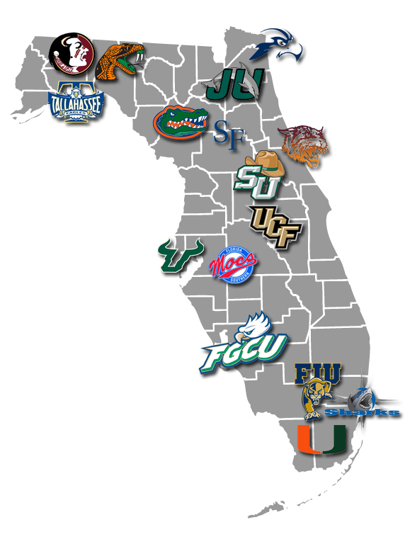



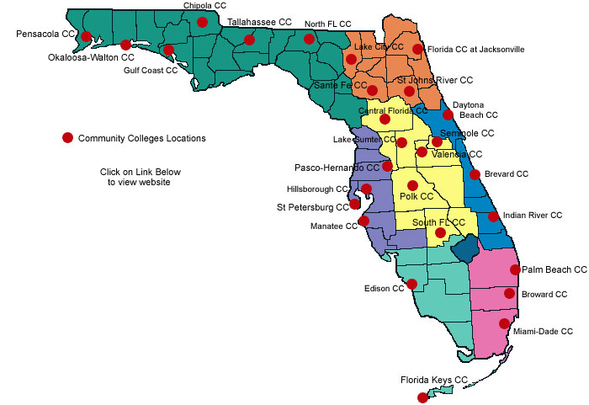

State